IELTS ACADEMIC TRAINING MODULE

IELTS WRITING

Name: Candidate Number:

WRITING TASK 1
You should spend about 20 minutes on this task.
The table shows information about metro systems in six different cities.
Summarise the information by selecting and reporting the main features and make comparisons where relevant.
Write at least 150 words.
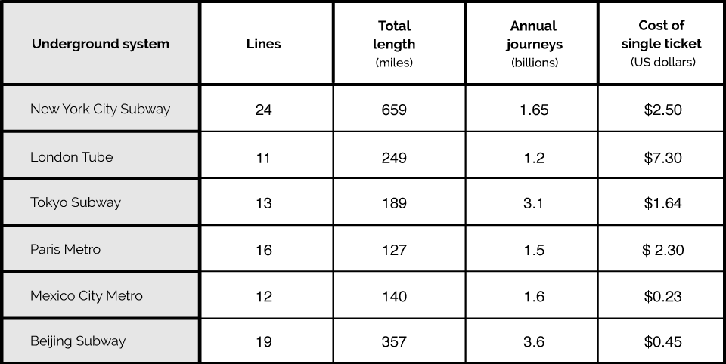

WRITING TASK 2
You should spend about 40 minutes on this task.
Some people believe that governments should have access to people’s mobile phone call records and messages for safety reasons. Others believe that this information is private and should not be available without permission.
Discuss both these views and give your opinion.
Give reasons for your answer and include any relevant examples from your own knowledge or experience.
Write at least 250 words

.

.

